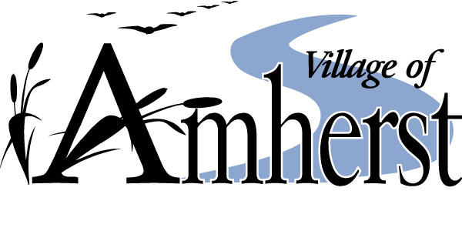
Amherst, Wisconsin
Notice of Meeting
VILLAGE BOARD MEETING
TUESDAY, JUNE 8, 2021 –7:00 PM
VILLAGE HALL – 160 MILL STREET

1. Call to Order
2. Roll Call
3. Pledge of Allegiance
4. Minutes of May 25, 2021
5. Persons Wishing to Address the Board
6. New Operator License: Karli Klismith, Laura Lutz, Bethany Juris and Wendy Wolfe
7. Wild Parsnips in the Village – Pete Arntsen Presentation
7. May Treasurer’s Report
8. Payment of the Bills
9. Renewal of Cigarette Licenses: Amherst Family Foods
10. Renewal of Liquor, Beer and Wine Licenses: Ambrosias Pub & Grill, Amherst Family Foods, Club Orlow, The Rivers Bar, O’Briens on Main, Go North, The Landmark
11. New Licenses: Thomas Orsund Memorial Foundation – Nelson Park and DS Ale Amherst Mart, Inc., 168 N Main Street
12. New Cigarette License: DS Ale Amherst Mart, Inc. 168 N Main Street
13. Temporary Beer/Wine License – Amherst High School Reunion Committee – Jensen Center, Sept 5, 2021
Committee Reports

Plan Commission: Overview Meeting

Utility: Well #1/#4 Update

Safety: Fire Inspections
Dog License Enforcement

Finance:

Personnel:

Administrative: Security of Buildings Update
Nelson Park Project Updates

Public Works: Wilson Street Sidewalk Project
Right of Way Ordinance Enforcement
House Numbering
Food Trucks

Library:

Fire Commission: Next Meeting: June 21, 2021
14. Adjourn

Marcy Peterson, CMC, WCMC
Clerk/Treasurer

